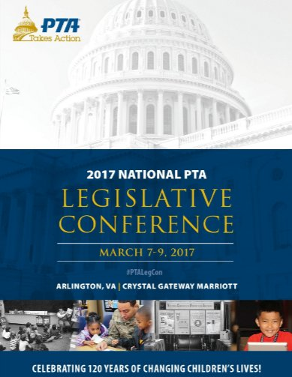
The Maryland Foster Parent PTA and the Maryland Foster Parent Association would like to thank National PTA for the invitation to present information concerning foster care advocacy and support during the 2017 Legislative Conference. Sam Macer, President of the MD Foster Parent PTA, the nation’s first PTA serving foster families, was provided the opportunity to share information with local PTA representatives from across the nation, about how they can support their local foster families.
National PTA, the largest volunteer child advocacy association in the nation, reminds our country of its obligations to children and provides parents and families with a powerful voice to speak on behalf of every child while providing the best tools for parents to help their children be successful students. Sam Macer reminded the local PTAs that they are experts in Parent Engagement and encouraged the attendees to share their expertise with foster families in their efforts to raise and sustain academic achievement for the nation’s most vulnerable youth. Sam also reminded the audience of the value of building successful partnerships. The Maryland Foster Parent PTA, chartered by the Maryland State PTA, and supported by the National PTA, has an effective partnership with the Maryland Foster Parent Association. Together, they are the foster parent voice on the Maryland State Department of Education’s, Superintendent’s Family Engagement Council and Maryland’s Social Service Administration’s Advisory Board.
Thank you, National PTA, for being an advocate for all children. President Maryland Foster Parent PTA

